


IS480 Project Proposal
Clinic Management System

uLinkers

Version Number 1
5 October 2016

Team Members:
- Teh Kaixin (kaixin.teh.2014@sis.smu.edu.sg) – Project Manager
- Nabilah Banu (nabilahbmnk.2014@sis.smu.edu.sg) – Business Analyst
- Nicole Goh (nicole.goh.2014@sis.smu.edu.sg) – Lead Front End Developer
- Chien Shu Yan (sychien.2014@sis.smu.edu.sg) – Assistant Front End Developer/ Quality Assurance
- Sean Kwok Yi Hui (seankwok.2014@sis.smu.edu.sg) – Backend Developer

Faculty Supervisor:
- Name

Sponsor and/or Clients (if any):
Ulink Assist Pte Ltd
- Linda Siow (exec@ulinkassist.com) - Executive

Project Overview

Project Description:
We propose to build a web-based Clinic Management System that allows simple coordination and integration of clinic activities to manage patient records and daily tasks. The new system will also provide analysis of data, which is useful for Ulink to make decisions and recommend suitable screenings to patients. There are currently 10 users in the company that will use this application on a daily basis.

Motivation:
The reason for doing this web application is to simplify user's interaction with the system. Currently, they are using a CRM System to manage their day-to-day tasks. We identified issues such as redundancy and rigidness, which imposed multiple limitations such as duplication of records and unnecessary functionalities for employees of Ulink. We aim to counter these limitations faced by reducing the number of steps required for users to navigate through the new system. Since most of the users are not as IT-savvy, the new system will ensure that the terms used are easy to understand. Intuitiveness in usage is important in our new system, to allow uLink to maximise the potential of the new Clinic Management System. This will not only improve productivity in carrying out their daily business processes but also allow them to collect insightful analytics, which will add Ulink in their decision-making.

Stakeholders:
Sponsor | Our sponsor and contact person is Ms Linda Siow from Ulink Assist Pte Ltd.
User | Ms Siow is one of the main users of the Clinic Management System. Other users include administrative staff, medical and Visa team of the company.

Deliverables:
The Clinic Management System is web application that employees of Ulink can use for their daily tasks such as handling of appointments for foreign patients. They can also gain insights from all the stored records and use it as decision-making tools.

Scope:
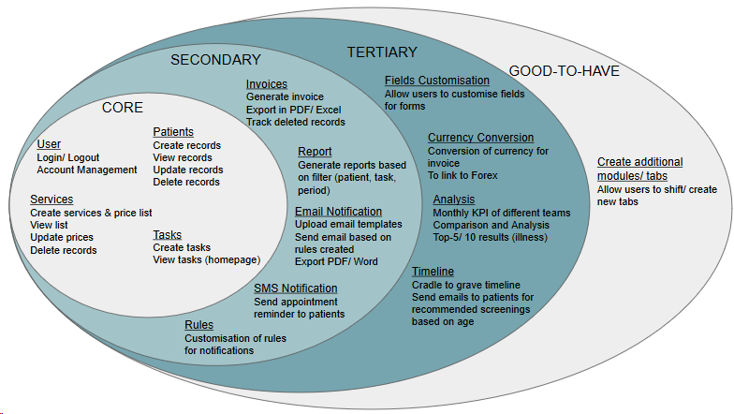

Project Plan

Project milestone:
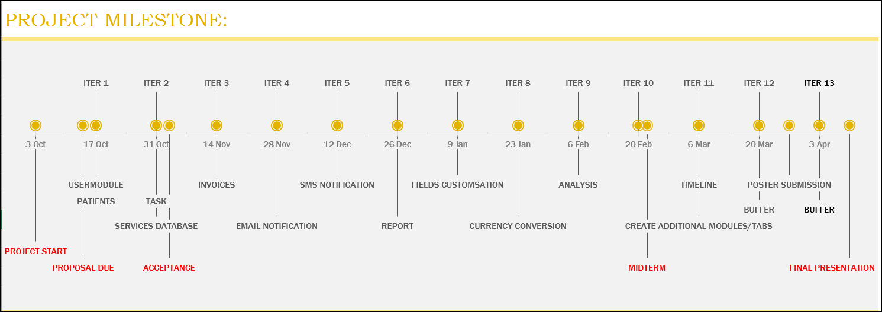

Risks:

Category | Description | Impact | Likelihood | Mitigation Steps
Technical | Unfamiliar with coding language like JavaScript and jQuery | May result in delay and bottleneck | Medium | Allocate time to familiarize with the coding language
Management | Allocation of too much/ little time for development of functions | May result in insufficient time for development of functions. | Medium | Include buffer time before final submission. More time is allocated to secondary and tertiary functions

Resource and reference:
Resource:
- GitHub private repo: distributed and source code management.
- Redhat Openshift Server: Cloud Server

Technology:
- jQuery Ajax, JSP Model 2, Twitter Bootstrap, HTML, Java, JavaScript, MySQL

API
Fixer.io, Solutions Infini

